**Team Members**: Denmar Ermitano Valentin Georgiev Tracey Vergara

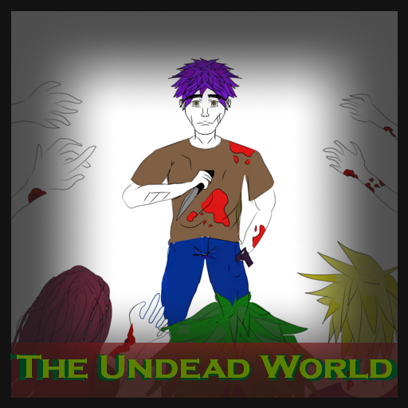**Title** The Undead World

**Tag line** “Will you survive the new reality of this world?”

**Genre** Shooter, Platformer, Zombie Apocalypse

**Target**  Teens

**Goal** Kill zombies and find safety

*Draft of Box Art*

**Plays like** Super Mario Brothers meets Zombie Apocalypse

*Popular Game A Popular Game B or twist*

**Core Mechanics**

1. Shooting mechanics: The user gets a gun. They use it to shoot zombies in order to survive and go to the next levels. This is the main combat system.
2. Platform-based navigation: The user travels through multiple doors to enter the next level. Each level is on

**Related Games (Optional, remove section if you don’t use it)**

1. ________________________________________________________________________________________

*Title Publisher or Developer Genre/Platform Year*

Super Mario Bros Nintendo Platform 1985

**Game Project Summary**

*Supporting Screenshot / Drawings / Collage for Worlds / Levels / Characters / Game Items*

The game revolves around the main character, trying to survive in a zombie ridden-world. Throughout the game, the player gets a different weapon and the more the player progresses, the better the weapon the protagonist gets. To progress, the player goes through doors to ultimately find safety while avoiding damage from zombies.

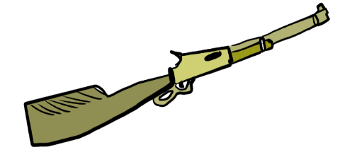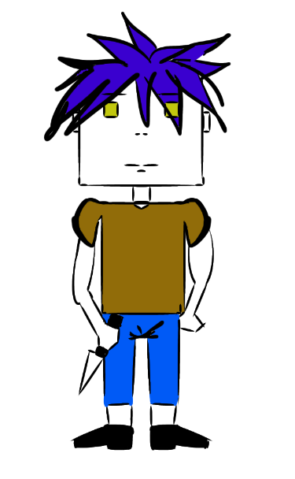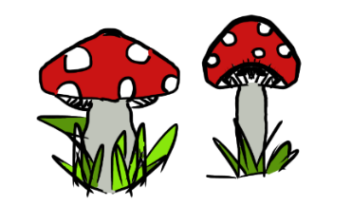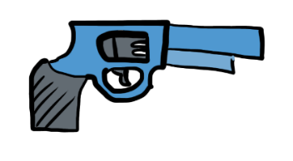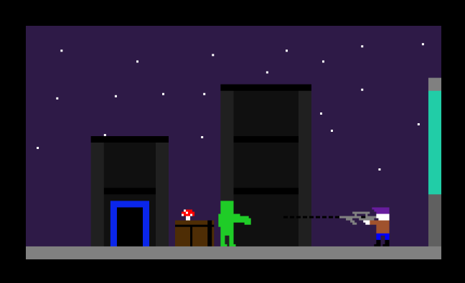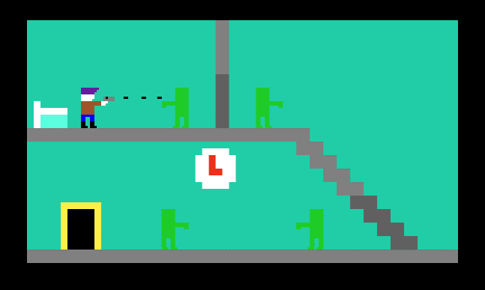

Character Design

Health Items

Level concepts

Sample Weapons

*Supporting Screenshot / Drawings / Collage for Worlds / Levels / Characters / Game Items*